Vol IX Book 02 — Federal Application-Aware Networking — Landing Zone Front Door
  - The catalog request that drives change-controlled landing-zone IaC and reconciles every allocation to the IPAM/DDI join key
SSA Cloud Services Team
2026-07-12 15:00 ET
INTERNAL — NOT FOR PUBLIC DISTRIBUTION

Draft Proposal — Subject to Review
Developed by the CSI Team (Cloud Services Infrastructure); not yet reviewed or approved by the SSA CIO Office, OIS, or leadership. Date Code: 2026-07-12 15:00 ET
Series Context — Volume IX Book 02. The infrastructure-as-code exists (Vol VI Book 01, infoblox-ddi-book/azure-alz-automation/); what is missing is the governed front door — the catalog request that drives it. This book puts a ServiceNow catalog item on the landing-zone IaC so a subscription, virtual network, or subnet is provisioned through an approved, change-controlled pipeline and reconciled to the authoritative IPAM/DDI record at allocation time.

What This Document Addresses
Landing-zone infrastructure-as-code is a solved problem in this series — Terraform and Bicep modules stand up subscriptions, networks, and subnets from reviewed source (Vol VI Book 01). But a module that anyone can apply from a laptop is not change control, and an address block allocated outside the naming plane is a CM-8 gap the moment it exists. The gap is the front door: the governed request that turns “run the module” into “an approved, evidenced, reconciled provisioning event.”
This book supplies that front door, reusing the exact pattern the DDI ServiceNow app already proves (infoblox-ddi-book/servicenow-app/): catalog request → approval / separation-of-duties → speculative Terraform plan → apply → validation gate → CMDB reconcile → close.

The Provisioning Loop
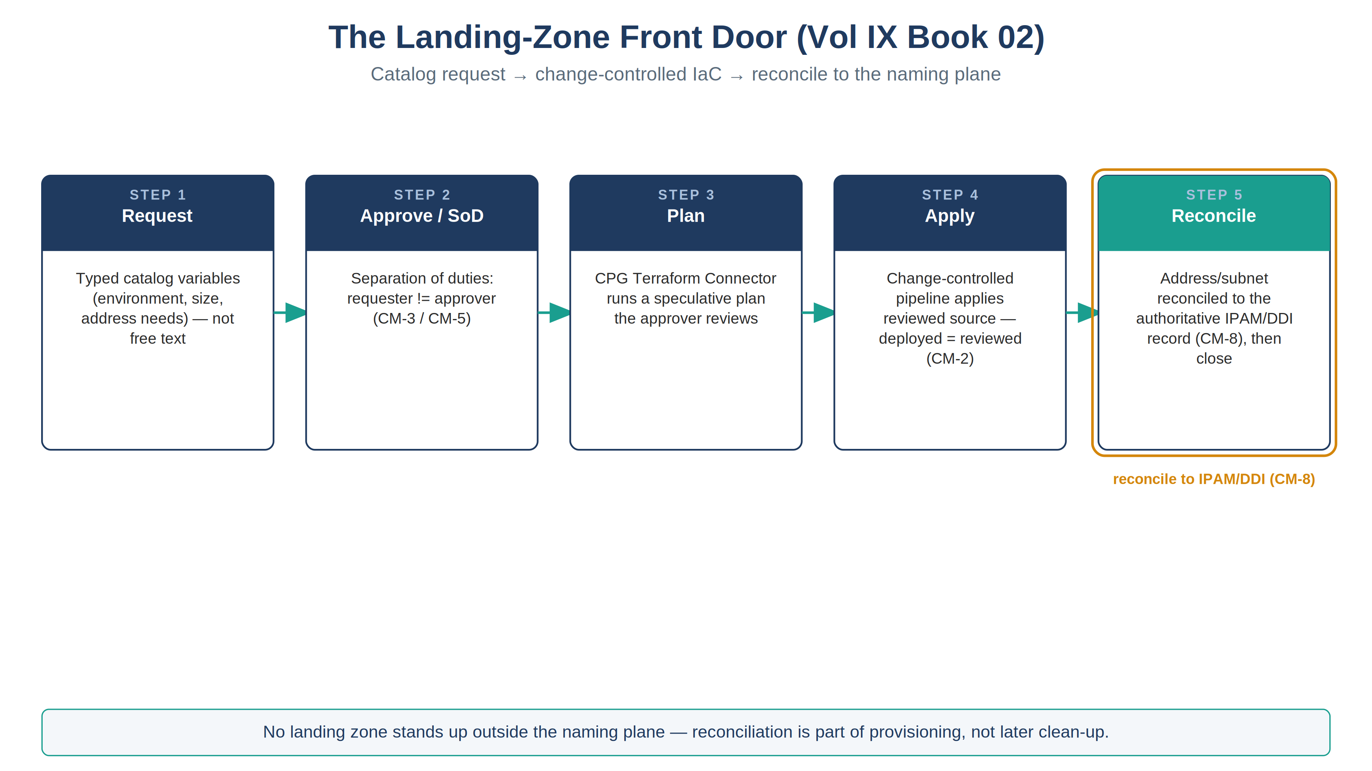
The landing-zone provisioning loop — request, approve with separation of duties, speculative plan, apply, reconcile to IPAM/DDI
Step | What happens | Control
1. Request | A catalog item captures the landing-zone parameters (environment, size, address requirements) as typed variables, not free text | —
2. Approve / SoD | The request routes through approval with separation of duties (requester ≠ approver) | CM-3, CM-5
3. Plan | The CPG Terraform Connector runs a speculative plan the approver reviews before any state changes | CM-3
4. Apply | On approval, the change-controlled pipeline applies the reviewed source idempotently — deployed state equals reviewed source | CM-2
5. Reconcile | The address/subnet allocation is written to and reconciled with the authoritative IPAM/DDI record | CM-8
6. Close | The validation gate confirms the landing zone matches intent; the change record and gate verdict are the evidence | CM-3, AU-2
No landing zone stands up outside the naming plane. Step 5 is the load-bearing one: an address block allocated by IaC but never reconciled to IPAM/DDI is shadow inventory (a CM-8 / BOD 23-01 finding) the moment it exists. The front door makes reconciliation part of provisioning, not a later clean-up.

Reuse — This Is the DDI App, Generalized
The DDI ServiceNow app (Vol VIII Book 07, infoblox-ddi-book/servicenow-app/) already implements this loop for DNS-backed subnet provisioning: a catalog item fronts a Terraform module through the CPG Connector, a MID-Server gate validates, and the Service Graph Connector reconciles to the CMDB. This book extends the same records to full landing-zone provisioning — same connectors, same in-boundary MID, same validation-gate discipline, broader module scope.

Closure Necessity

Closure Necessity — IaC without a governed front door is not change control
Volume VI proves the mechanism: landing zones expressed as reviewable source close CM-2/CM-3/CM-6. This book makes the invocation of that source governed — an approved, SoD-gated, evidenced provisioning event reconciled to the naming plane. Without the front door, the same modules are a click-path with no approval trail and no guarantee the allocation reached IPAM — CM-3 becomes an assertion and CM-8 forks. The IaC is necessary; the governed front door is what makes it assessable.

NIST SP 800-53 Rev 5 Control Closure — Authorities Closed Here
Generated from the compliance spine (aan-compliance-spine.yml); not hand-edited here.
Authorities Closed Here — Landing Zone Front Door (catalog → IaC → CMDB) († = Closure-Necessity anchor: no alternate closure path)
Control | Title | Closing mechanism (function, not product) | Accreditation gate | Authority drivers | Evidence slot | FedRAMP 20x KSI | Tool-attestable?
CM-8 | System Component Inventory | Subnet/address allocation reconciled to the authoritative IPAM/DDI record (CM-8) at provisioning time — no landing zone stood up outside the naming plane | FedRAMP Moderate | NIST SP 800-53 Rev 5; CISA BOD 23-01 | Network | KSI-PIY | No
CM-3 | Configuration Change Control | Catalog approval → speculative Terraform plan → apply → validation gate → CMDB close as the CM-3 gate for landing-zone changes | FedRAMP Moderate | NIST SP 800-53 Rev 5; OMB Circular A-130 | Security / supply chain | KSI-CMT | No
CM-2 | Baseline Configuration | Landing-zone catalog request drives the change-controlled IaC pipeline (Terraform/Bicep) — deployed state equals reviewed source | FedRAMP Moderate | NIST SP 800-53 Rev 5; OMB Circular A-130 | Security / supply chain | KSI-CMT | No

Honest Limits
- The front door governs provisioning; drift after apply is a Vol VII Book 03 (Azure Policy) concern — the two compose (provision governed, then monitor drift).
- The speculative plan is only as safe as the module’s blast radius; destructive changes carry a heightened approval gate.
- Reconciliation depends on the IPAM/DDI backend chosen in the Volume VIII / InfoBlox decision; until that lands, the reconcile step targets whatever authoritative record exists.

Cross-References
- Vol VI Book 01 (Landing Zone & Network as Code) — the IaC this front door drives.
- Vol VIII Book 07 / infoblox-ddi-book/servicenow-app/ — the DDI catalog→Terraform→gate→CMDB pattern this book generalizes.
- Vol I Book 01 (IPAM/DDI) — the authoritative record allocations reconcile to (CM-8).
- Vol VII Book 04 — where the provisioning evidence becomes attestation.

Provenance
Draft. ServiceNow, the CPG Terraform Connector, Terraform/Bicep, and Azure ALZ are deployed examples; the catalog→approve/SoD→plan→apply→reconcile→close discipline is the invariant. The figure above is authored as committed house-style SVG per ADR-093, rendered to PNG at 3× for crisp .docx zoom.

